Bluejet Analysis Document Created on 24-Nov-18

BlueJet Analysis Documet
2018
SEO UPDATION

Contents
1.TILTE TAGS: 3
2.META DESCRIPTION: 5
3.CONTENT: 7
4.BACK LINK ACTIVITES: 8

1.TILTE TAGS:

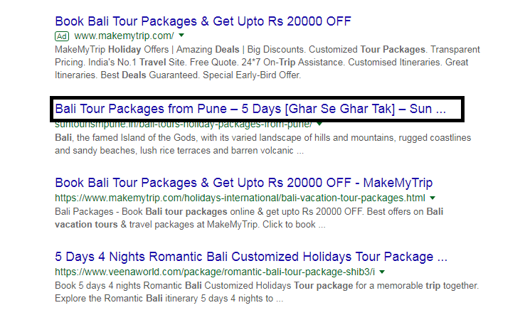

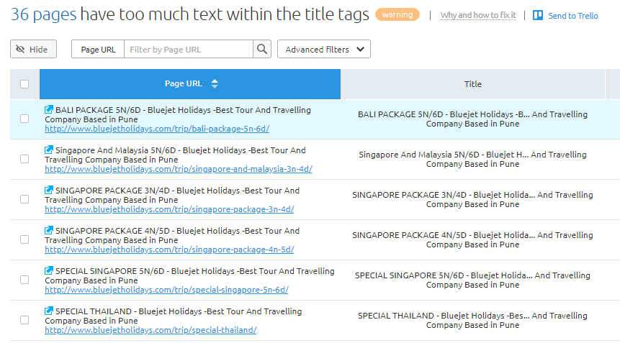

We have work on to add and improve title tag on Bluejet Holidays website. For better searching ranking on search engine ranking page.

2.META DESCRIPTION:

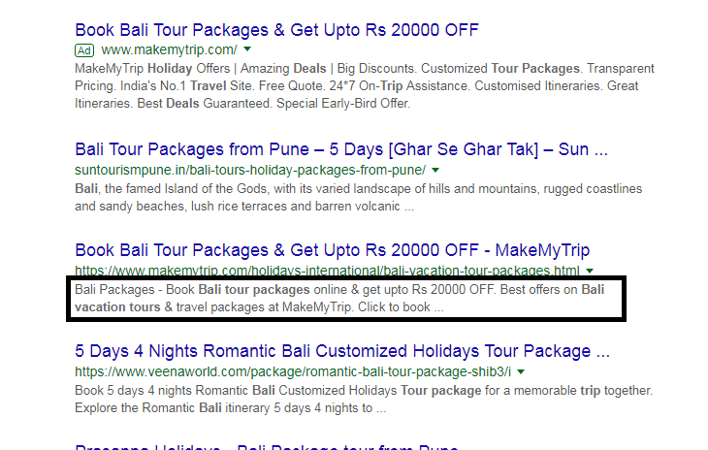

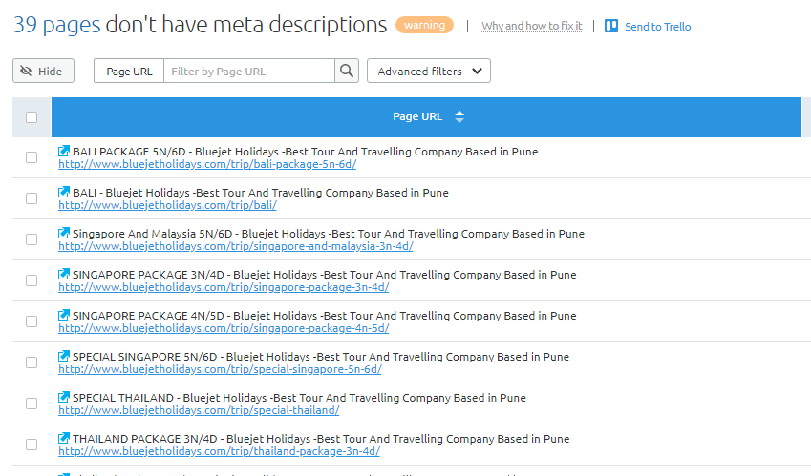

We have work on to add and improve meta description tag on Bluejet Holidays website. For better searching ranking on search engine ranking page.

3.CONTENT:

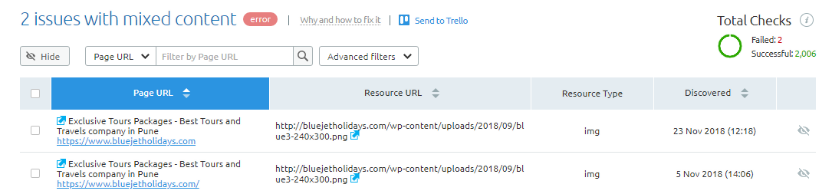

We will work on to remove mixed content on different pages and adding some new content on website. Adding new and unique content on website including primary and secondary keyword which helps website to get better searching ranking on search engine ranking page.

4.BACK LINK ACTIVITES:

We will work on off page activities like dropping our website link on related website. Through back link activities we will increase footfall to our website and through that increase website traffic. which helps to get better rank on search engine ranking page.

