Destination SEO | BJH
Destination SEO for BlueJetHolidays- 14-Nov-18 |  | Hrushikesh Patil

Contents
1. Singapore SEO Details: 3
2. Thailand SEO Details: 5
3.Brokan Links Details: 6
4.Add Plugins: 8

1. Singapore SEO Details:

Sr.No | Screenshot | Description
1 | 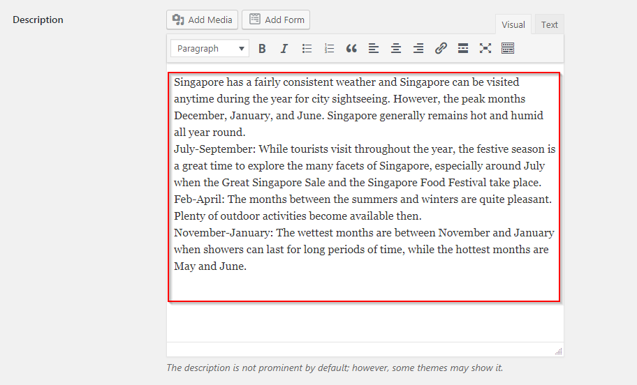 | Before Changes.
2 | 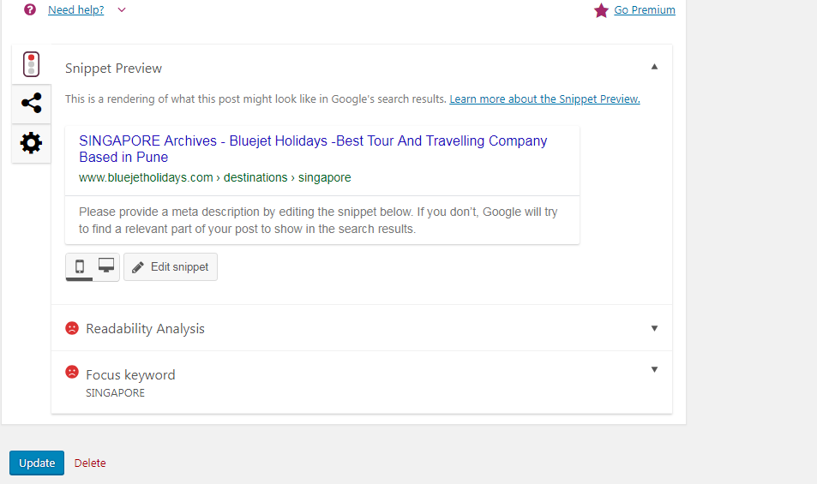 | Before changes.
3 | Singapore has a fairly consistent weather and Singapore can be visited anytime during the year for city sightseeing. However, the peak months December, January, and June. Singapore generally remains hot and humid all year round.  July-September: While tourists visit throughout the year, the festive season is a great time to explore the many facets of Singapore, especially around July when the Great Singapore Sale and the Singapore Food Festival take place.  Feb-April: The months between the summers and winters are quite pleasant. Plenty of outdoor activities become available then.  November-January: The wettest months are between November and January when showers can last for long periods of time, while the hottest months are May and June. | Content before changes
4 | 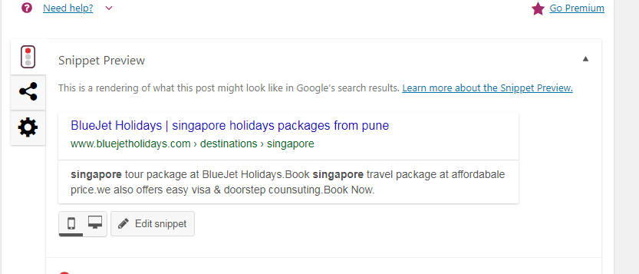 | After changes
5 | 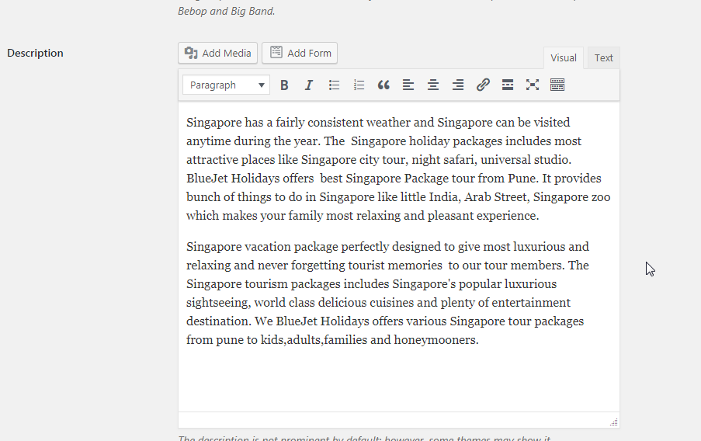 | Content after changes.
6 | 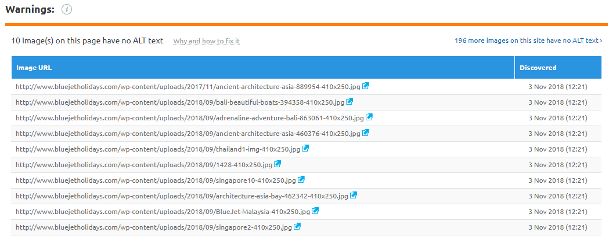 | Befor ALtImages tag

2. Thailand SEO Details:

Sr.No | Screenshot | Description
1 | Thailand although known for its climates which varies throughout the year. You can plan Thailand tour packages with BlueJet Holidays. Thailand is among the most visited tourist place in the world. In Thailand holiday packages includes exciting destination like long beaches, tropical jungles, zoo parks.  Thailand adored the word for its Thai cuisine known for its culture, warm and relaxed gesture, fresh seafood all emerge in Thailand vacation packages. Thailand is fun loving, famous for shopping, world class resorts, water sports. we BlueJet Holidays provides most luxurious, relaxing and affordable Thailand holiday packages for family and honeymooners. Thailand travel packages gives lifetime experience to your kids, family and couples. | Content after changes

3.Brokan Links Details:

4 | 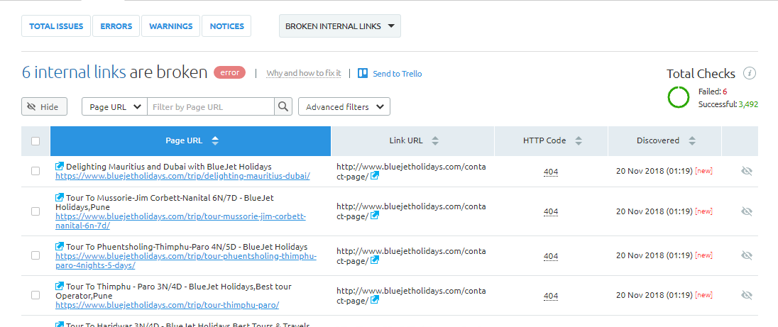
5 | 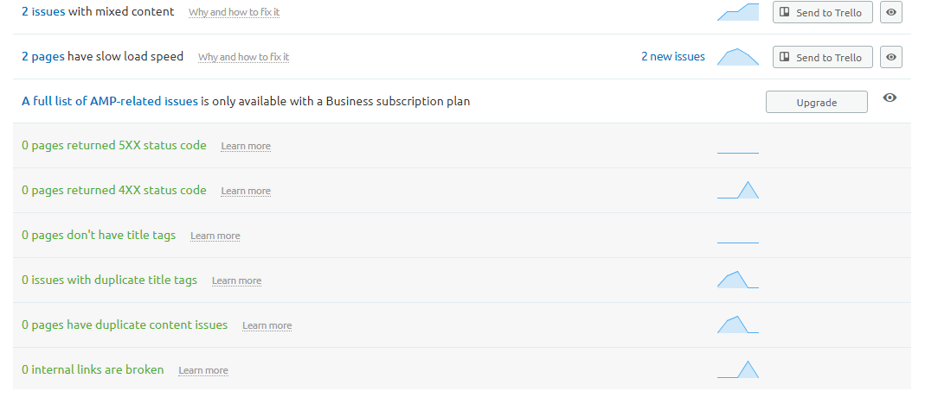 | After changes.

4.Add Plugins:

Plugins Name: | Features:
- Broken Link Checker | Checks your blog for broken links and missing images and notifies you on the dashboard if any are found.
- EWWW Image Optimizer | Reduce file sizes for images within WordPress including NextGEN Gallery and GRAND FlAGallery. Uses jpegtran, optipng/pngout, and gifsicle.
- SSL Insecure Content Fixer | Clean up WordPress website HTTPS insecure content.
- Autoptimize | Optimize your website's performance: JS, CSS, HTML, images, Google Fonts and more!

